**6.1 Introduction to AT command**

AT commands are commands used for connection and communication between terminal equipment and PC applications. Each AT command line can only contain one AT command.

For sending AT commands, in addition to the two AT characters, it can receive up to 1056 characters in length (including the last empty character).

**Each AT command must occupy a separate line, starting with AT, and ending with press enter keyboard to wrap.**

The following is an introduction to some commonly used AT command parameters.

For specific AT commands, you can check the files in the AT command of WIFI module folder.

Note: Before you test these command, you need to write **“wifi_AT.bin”** into K210 board.

1. **Basic instructions**

1.1 AT

Test whether the AT instruction is normal, when normal, it will return OK.

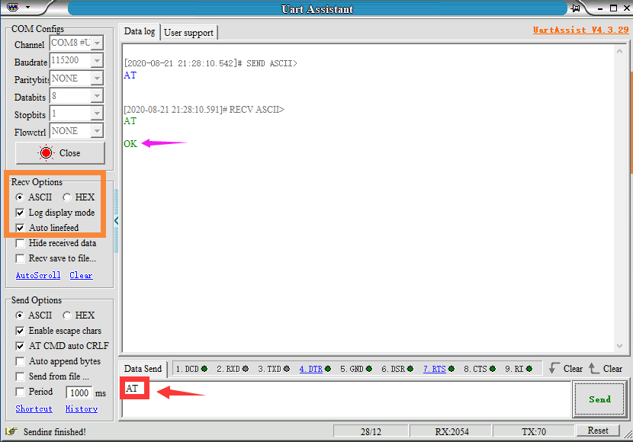

1.2 AT+RST

Restart WIFI module, return OK.

As shown below.

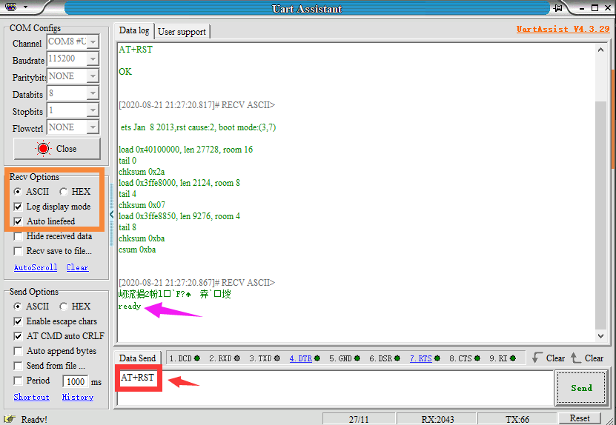

1.3 AT+GMR

View version information, display current version number, return OK.

As shown below.

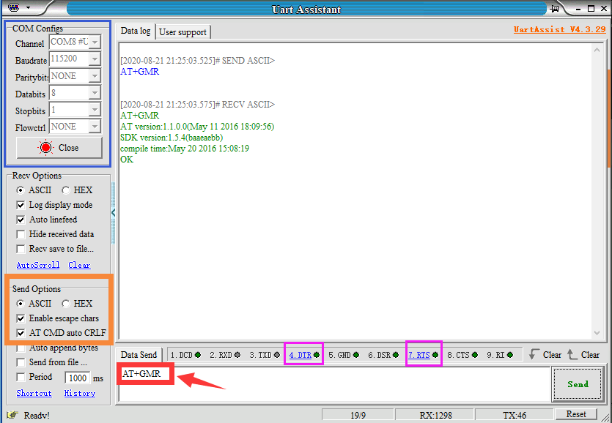

1.4 AT+RESTORE

Restore factory Settings, return ready. As shown below.

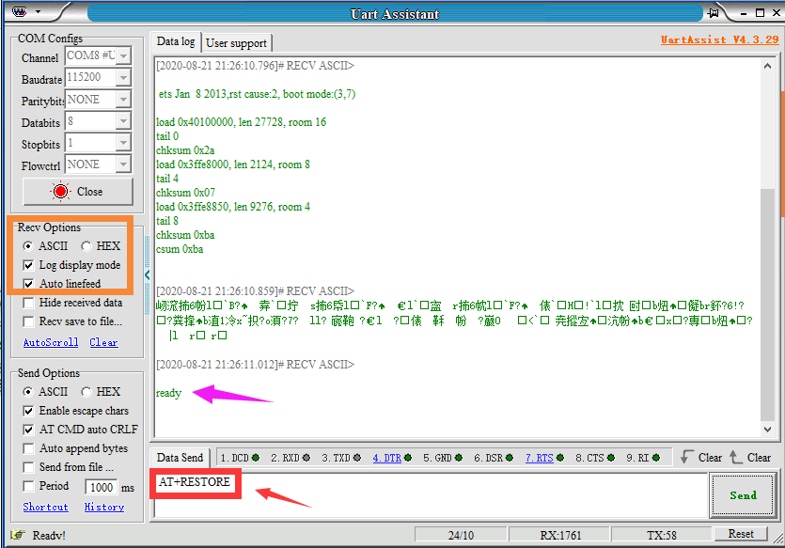

**2. WiFi function AT instructions**

2.1 AT+CWMODE?

View WIFI application mode, return + CWMODE:OK

As shown below.

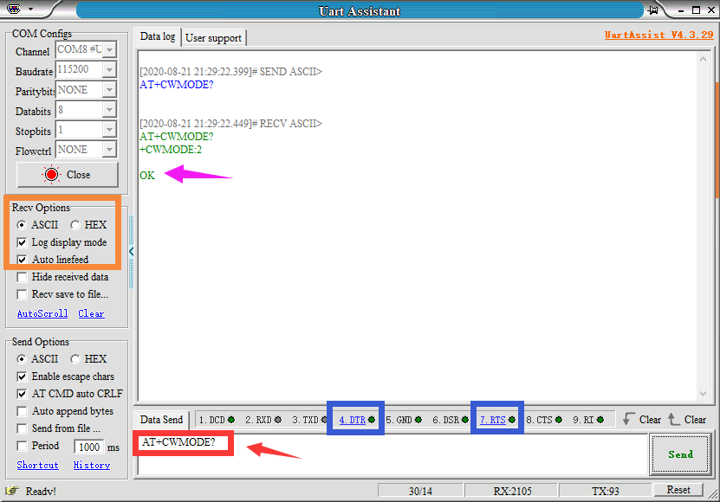

2.2 AT+CWMODE_DEF=XXX

Set the wifi application mode, eturn to OK. The command will take effect after restarting.

mode:

1 - Station mode (Only connect to your home WIFI)

2 - AP mode (Self-heating point)

3 - AP+Station mode

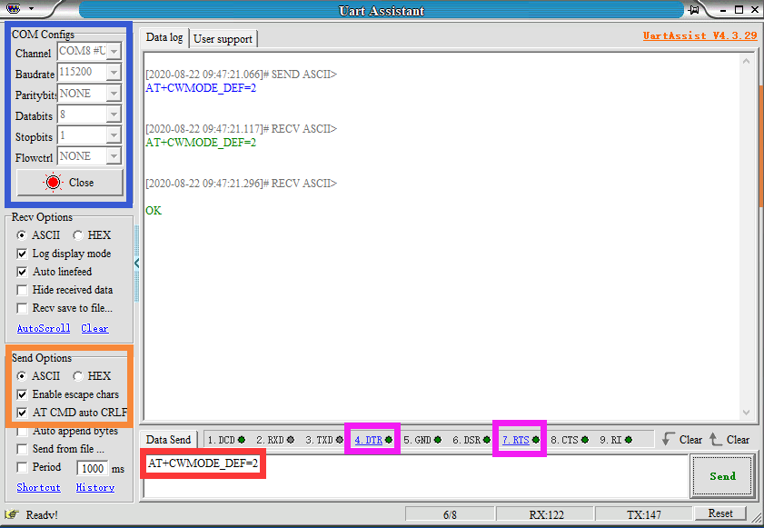

Tip:

station: client, AP: server. This command will be written to the flash, restarting can save the setting status.

2.3 AT+CWJAP_DEF="WiFi信号","WiFi密码"：连接WiFi，保存到flash。（CWMODE=1/3时有效）

2.4 AT+CWLAP ：扫描周围的WiFi热点。（CWMODE=1/3时有效）

2.5 AT+CWQAP ：断开WiFi连接。（CWMODE=1/3时有效）

三、作为客户端

1.AT+CIPSTART="TCP","服务器IP",远程端口号：连接到TCP服务器。

2.AT+CIPCLOSE：断开TCP连接。

3.AT+SAVETRANSLINK=1," 服务器IP ",远程端口号,"TCP"：连接服务器，开启透传模式，写入flash，开机自启动，需要重启WiFi模块才有效。

4.+++：退出透传模式，要取消AT指令自动回车。

**3. As a client**

3.1 AT+CIPSTART="TCP","server IP", remote port number: connect to TCP server.

3.2 AT+CIPCLOSE: Disconnect the TCP connection.

3.3 AT+SAVETRANSLINK=1, "server IP", remote port number, "TCP": connect to the server, open the transparent transmission mode, write to the flash, start automatically after booting, and it need to restart the WiFi module to be effective.

3.4 +++: Exit the transparent transmission mode, **no choose AT CMD auto CRLF.**

**4. As a server**

4.1 AT+CIPMUX=1: Open a multi-terminal connection.

4.2 AT+CIPSERVER=1, remote port number: Open server mode.